Project Design Phase-II
Technology Stack (Architecture & Stack)

Date | 20 February 2026
Team ID | LTVIP2026TMIDS82947
Project Name | ShopSmart
Maximum Marks | 4 Marks

Technical Architecture:
User Interface:
- Responsive Web UI
- Built using React components
- Allows product browsing, cart management, and checkout
Application Logic:
- Frontend: React JS for single-page application and user interactions
- Backend: Node.js with Express.js for APIs
- Product Search & Filtering Logic using JavaScript functions
- Cart & Checkout Workflow integrated with REST API
Database & Storage:
- Database: MongoDB for storing user data, product catalog, orders, and cart
- Authentication: Firebase Auth (optional) or custom JWT-based system
- Storage: Cloudinary or Firebase Storage for storing product images
Payment Integration:
- Razorpay / Stripe for secure online transactions
- Webhooks for payment confirmation
Infrastructure:
- Hosted on Render / Vercel / Heroku / Netlify
- CI/CD via GitHub
- Scalable using Docker (optional for future enhancement)
External Interfaces :
- Payment gateway API (e.g., Razorpay/Stripe)
- Firebase / Google Auth for optional login
- Email service (e.g., Nodemailer + Gmail SMTP) for order confirmations

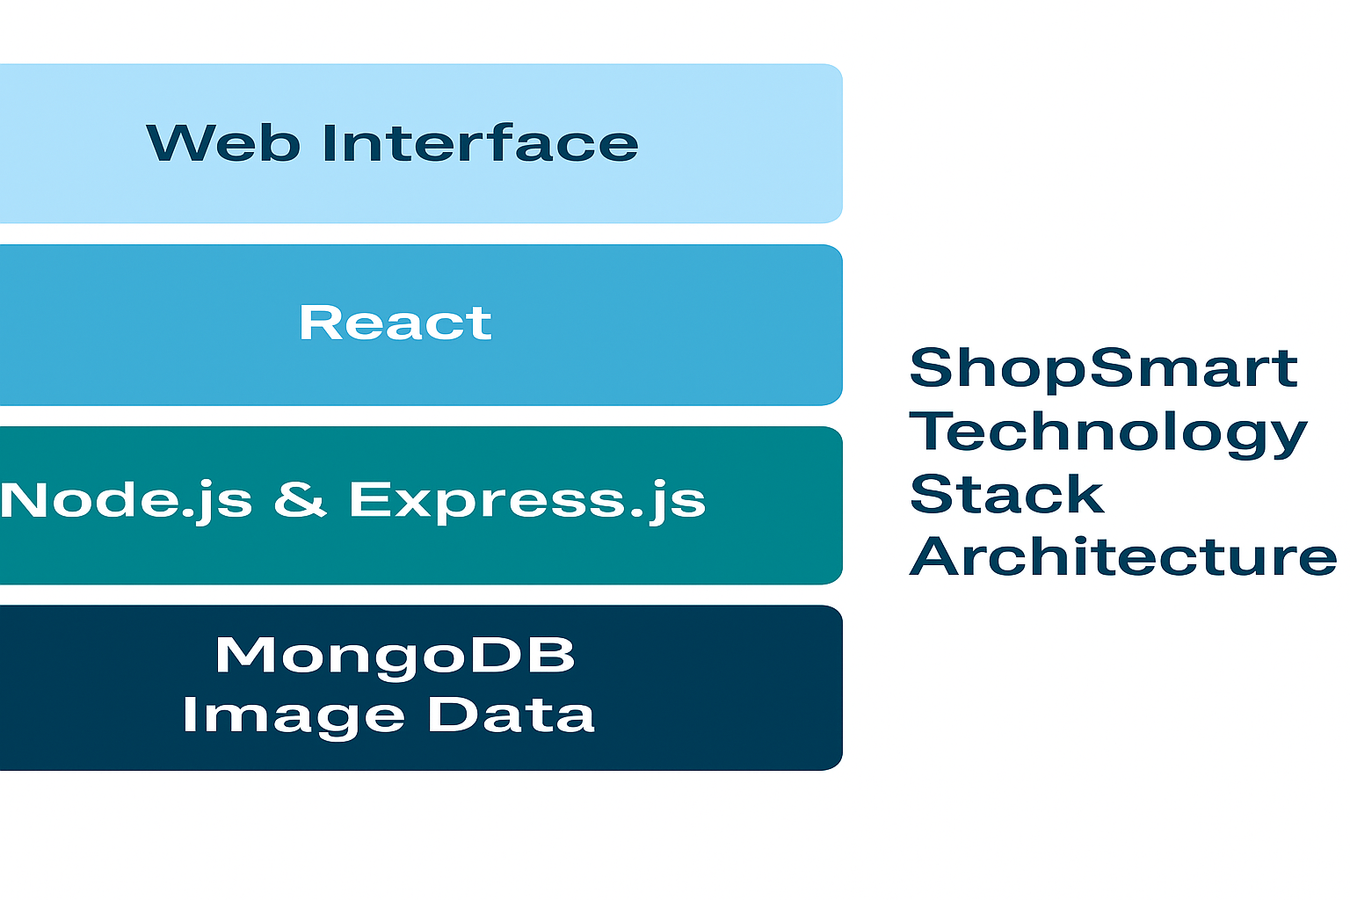

Table-1 : Components & Technologies:
S.No | Component | Description | Technology
 | User Interface | Web UI for shopping | React JS, HTML, CSS, Bootstrap
 | Application Logic-1 | Product search, filter, cart logic | JavaScript, React Hooks
 | Application Logic-2 | API logic and backend | Node.js, Express.js
 | Database | Store users, products, orders | MongoDB
 | File Storage | Product image uploads | Firebase Storage / Cloudinary
 | Payment Gateway | Secure payment process | Razorpay / Stripe
 | Infrastructure | Deployment & scaling | Vercel / Heroku / Netlify / Docker

Table-2: Application Characteristics:
S.No | Characteristics | Description | Technology
 | Open-Source Frameworks | Frameworks and libraries used | React JS, Node.js, Express, MongoDB
 | Security Implementations | Data safety and access control | JWT Auth, HTTPS, Password Hashing (bcrypt)
 | Scalable Architecture | Designed to support more users/products | RESTful API, modular components, Docker
 | Availability | Accessible across platforms and regions | Cloud hosting with 99.9% uptime
 | Performance |  | Lazy loading, caching, optimized DB queries
  Optimized browsing and purchase workflow

